**Task 1:** Load these files:

* AdventureWorksCustomers.xlsx → rename as Customers
* AdventureWorksProducts.xlsx → rename as Products
* AdventureWorksProductCategories.xlsx → rename as Categories
* AdventureWorksProductSubcategories.xlsx → rename as Subcategories

**Task 2:** Sort Sales2015 table by OrderQty descending.

**Task 3:** Append Sales2015, Sales2016, and Sales2017 into one combined table called AllSales.

**Task 1:** Load these files:

* AdventureWorksCustomers.xlsx → rename as Customers
* AdventureWorksProducts.xlsx → rename as Products
* AdventureWorksProductCategories.xlsx → rename as Categories
* AdventureWorksProductSubcategories.xlsx → rename as Subcategories

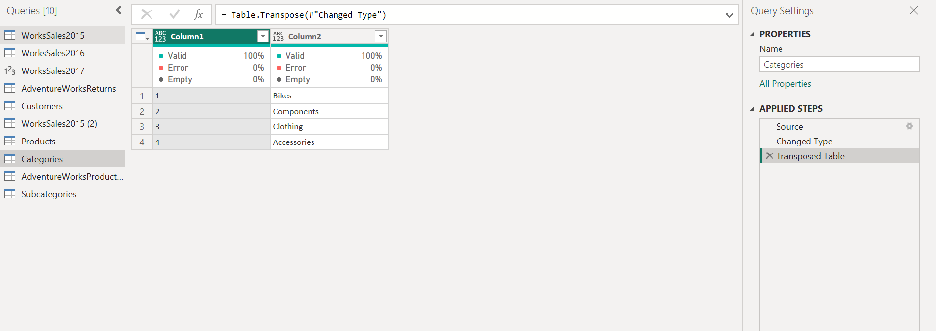

**Task 2:** Sort Sales2015 table by OrderQty descending.

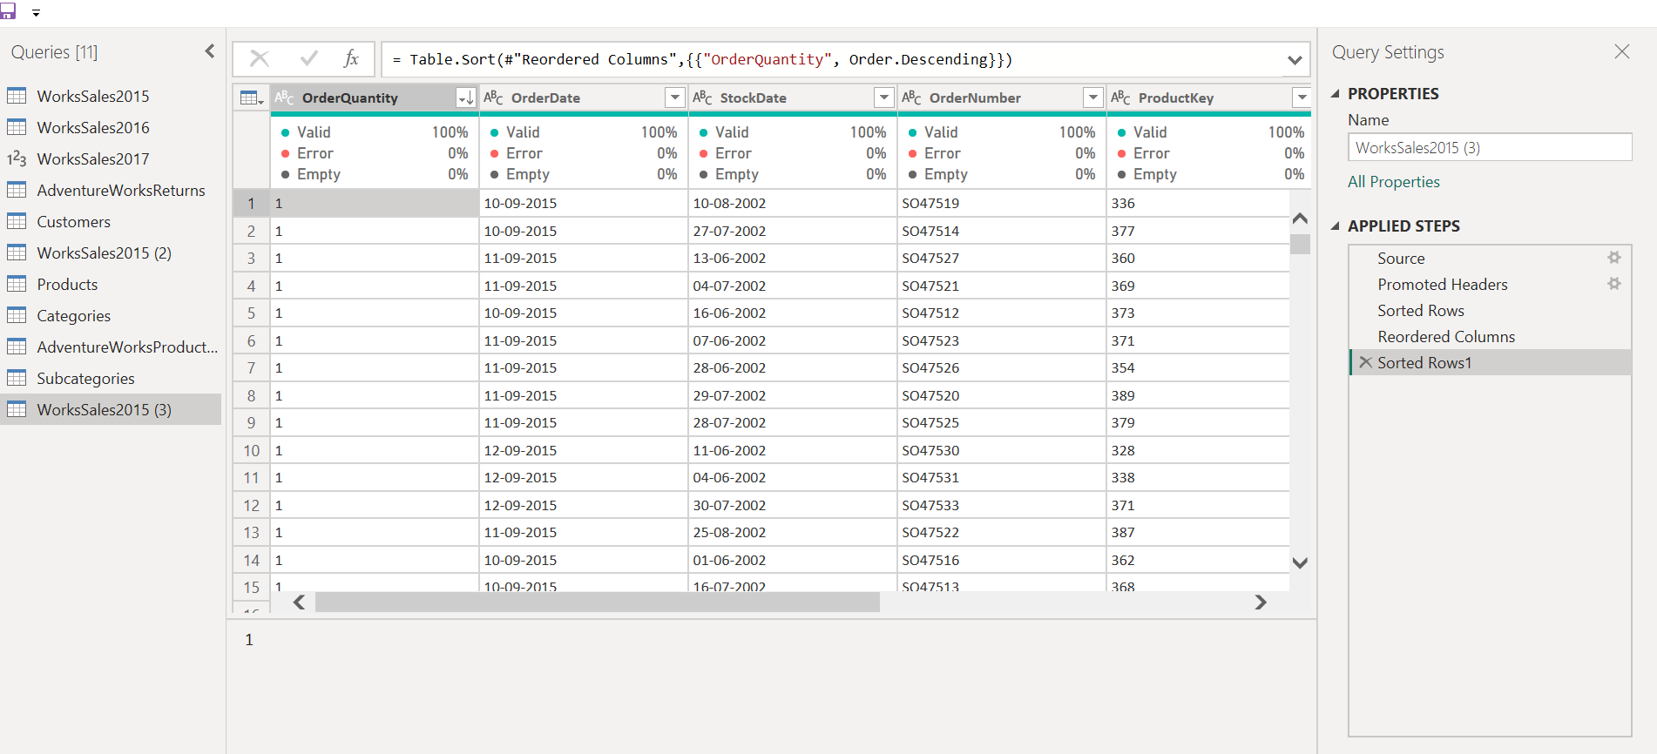

**Task 3:** Append Sales2015, Sales2016, and Sales2017 into one combined table called AllSales.

